Assignment :1

1.Write a program to check whether a number is even or odd.

Code:

void main()

{

int num;

printf("enter the number%d",&num);

if(num%2==0) {

printf("%d is even number",num);

}

Else {

printf("%d is odd number",num);

}

}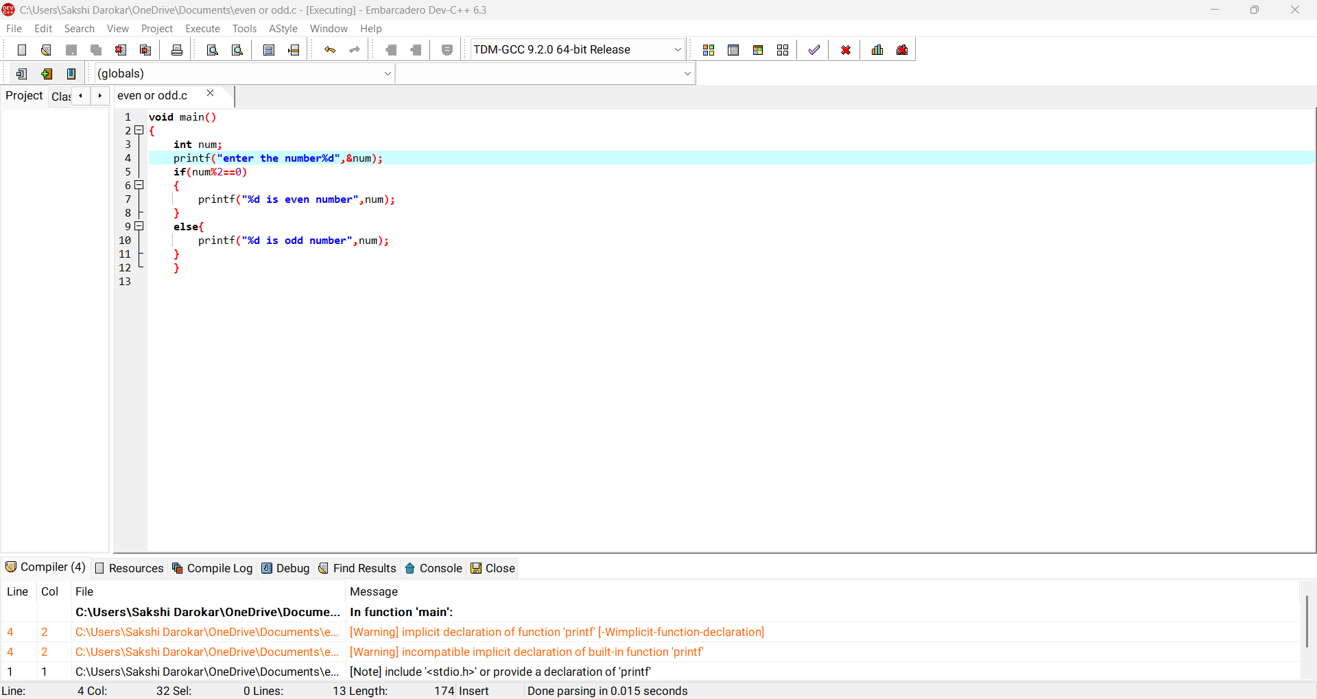

Output:

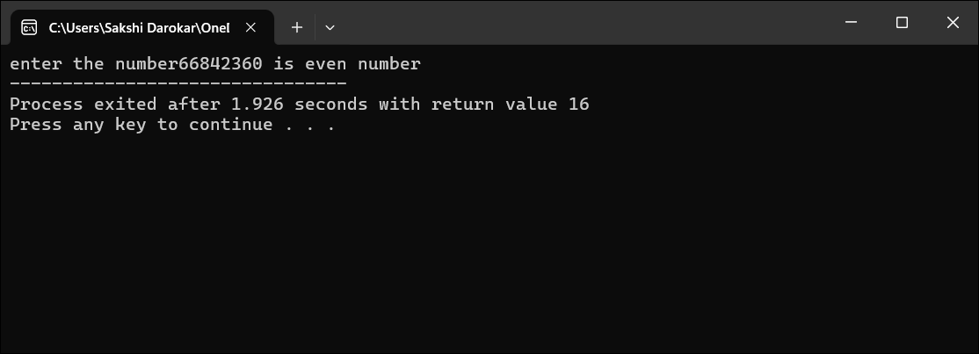

2.Write a program to check given 3 digit number is palindrome or not.

Code:

void main() {

int num, first, middle, last;

printf("Enter a 3-digit number%d",&num);

first = num / 100;

middle = (num / 10) % 10;

last = num % 10;

if (first == last) {

printf("%d Palindrome\n",num);

} else

printf("%d Not Palindrome\n",num);

}

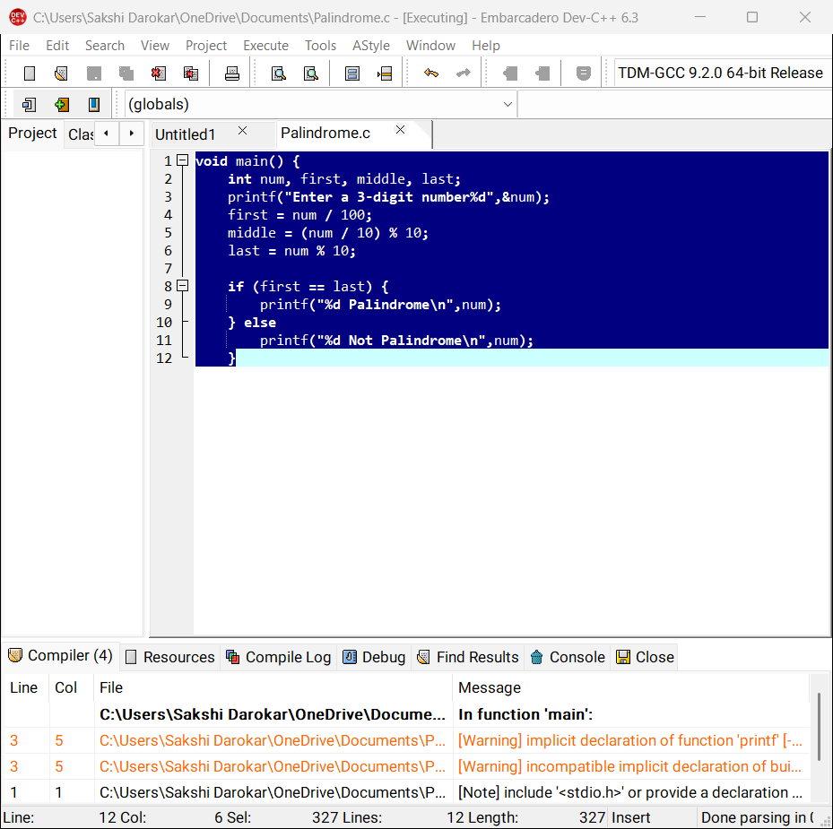

output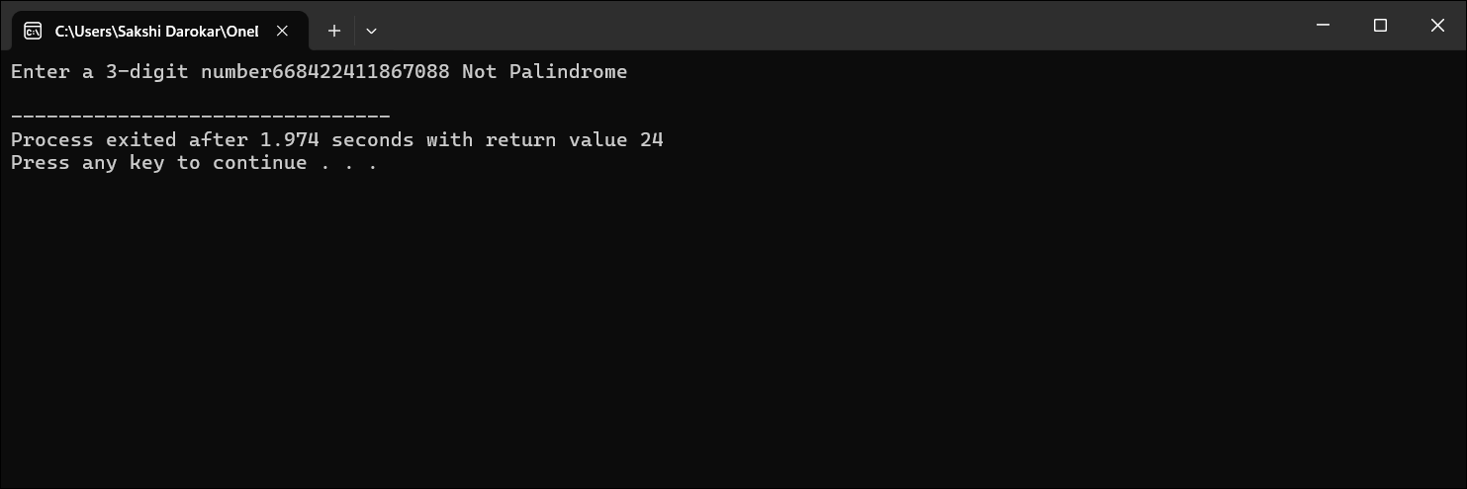

3. Write a program to check whether a given year is a leap year.

void main() {

int year;

printf("Enter a year %d", &year);

if ((year % 4 == 0 && year % 100 != 0) || (year % 400 == 0)) {

printf("%d is a Leap Year.\n", year);

} else

printf("%d is NOT a Leap Year.\n", year);

}

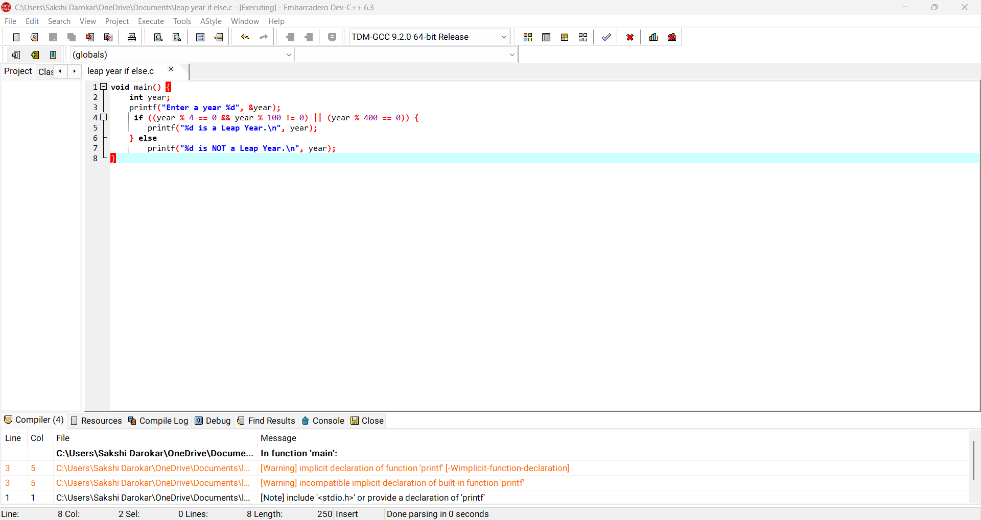

Output:

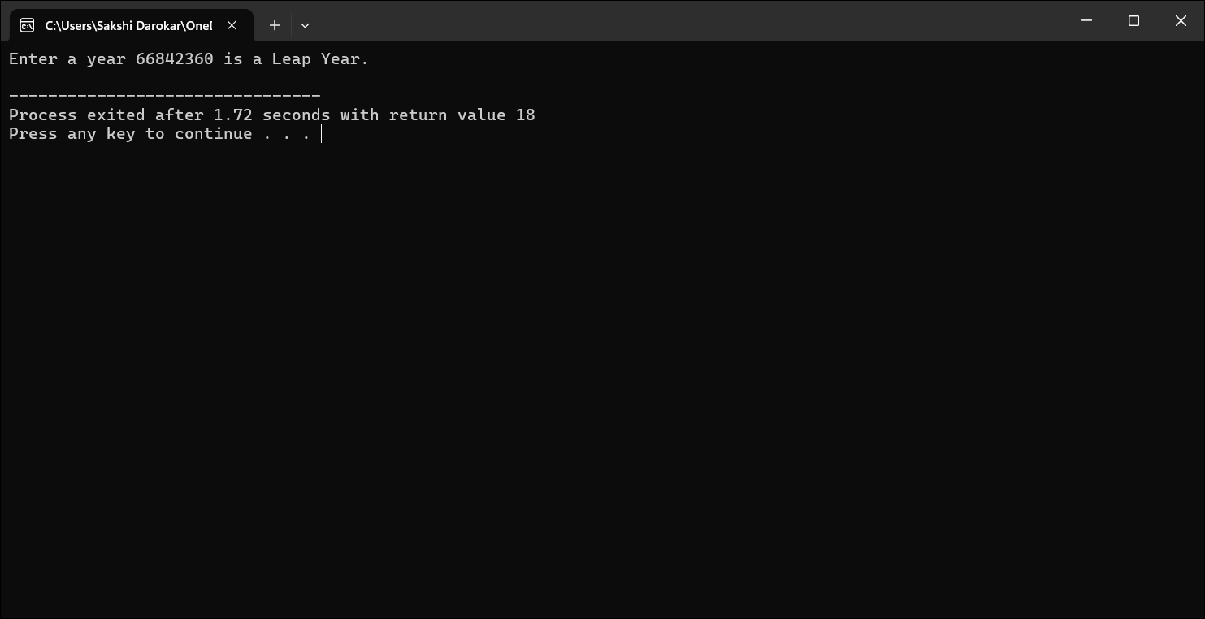

4. Write a program to check whether a person is eligible to vote (age≥18)

void main() {

int age;

printf("Enter age %d", &age );

scanf("%d", &age);

if (age >= 18)

printf("Eligible to vote");

else

printf("Not eligible to vote");

}

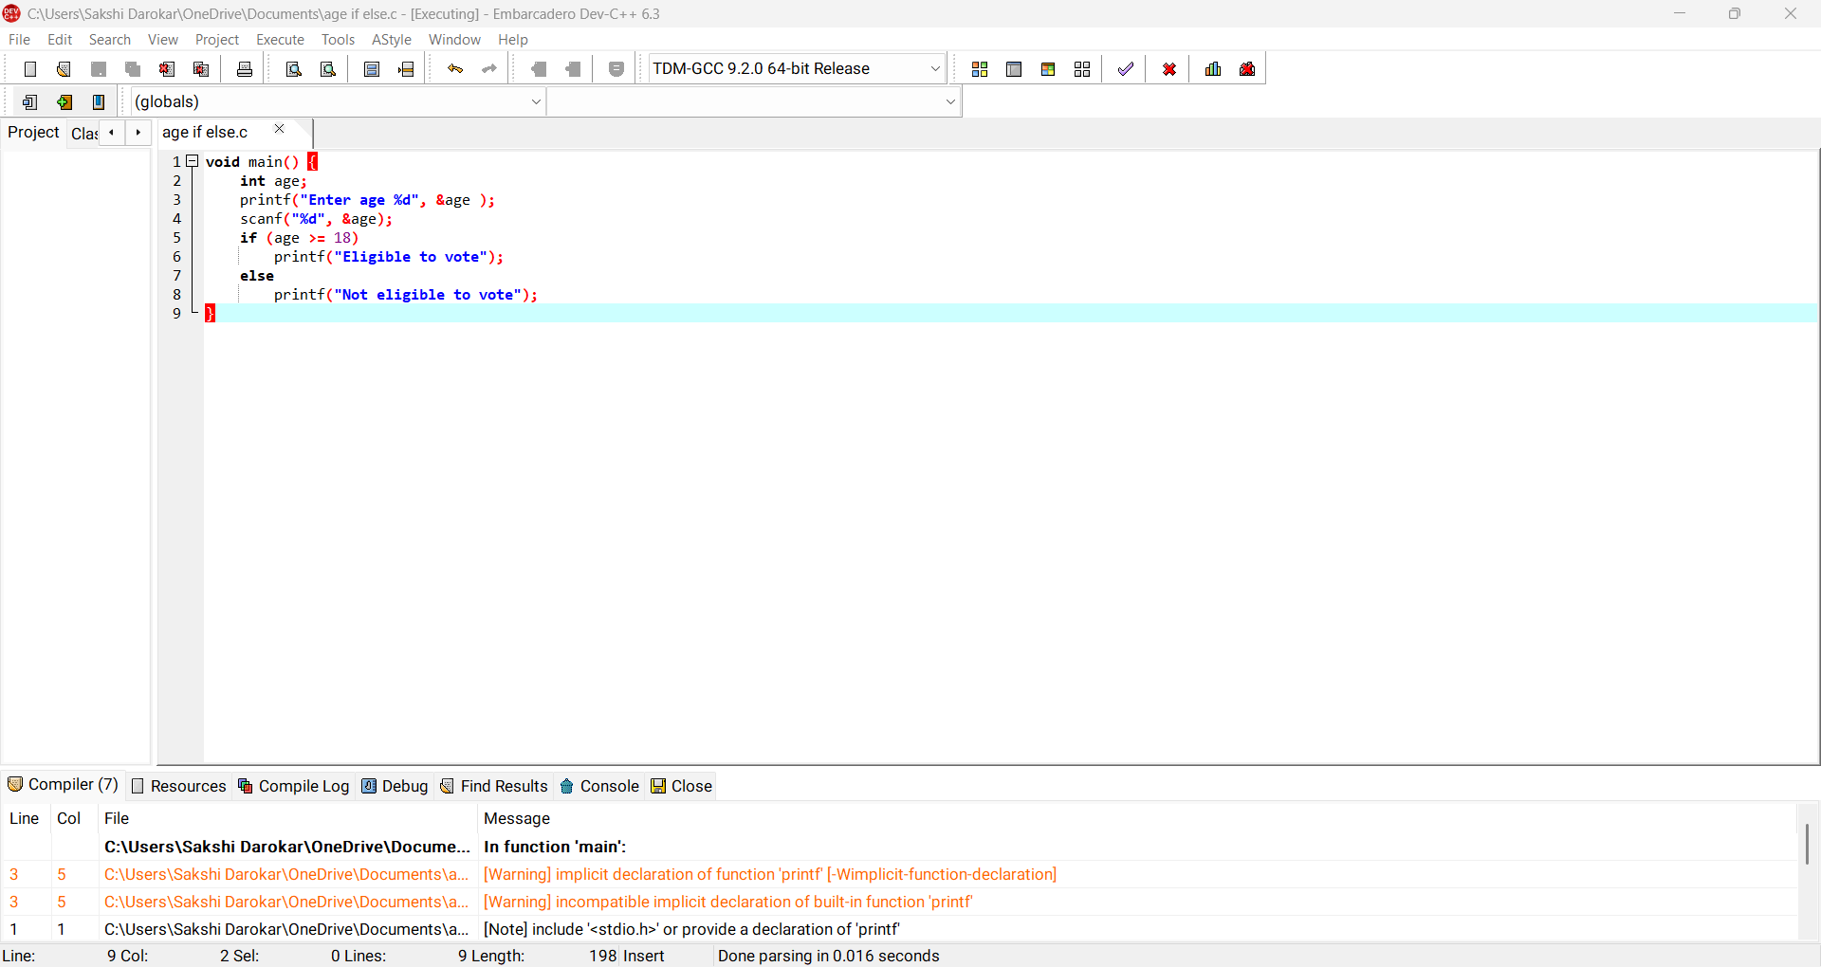

Output:

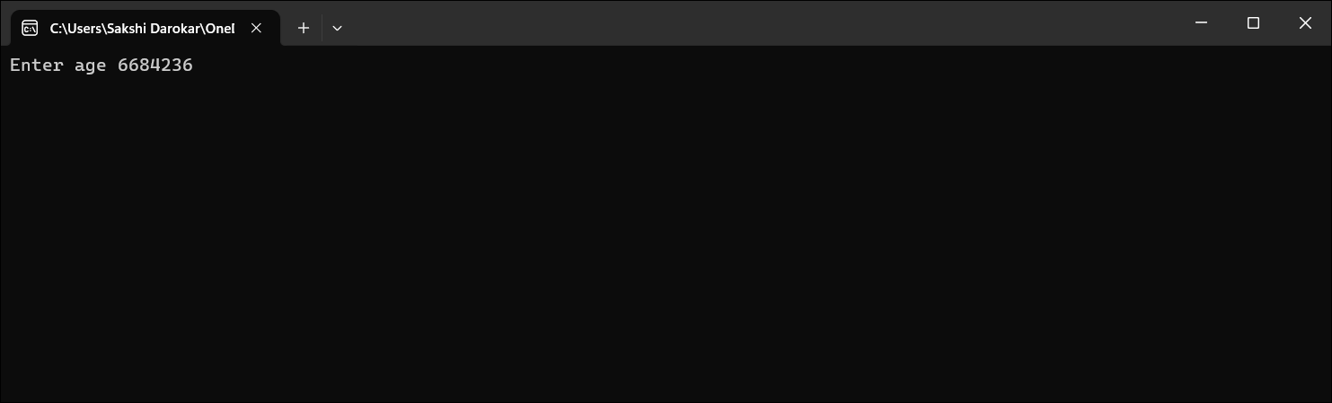

5. Write a program to ck whether a given o is uppercase or lowercase.

void main() {

char ch;

printf("Enter a character %c", &ch );

if(ch >= 'A' && ch <= 'Z')

printf("Uppercase");

else

printf("Lowercase");

}

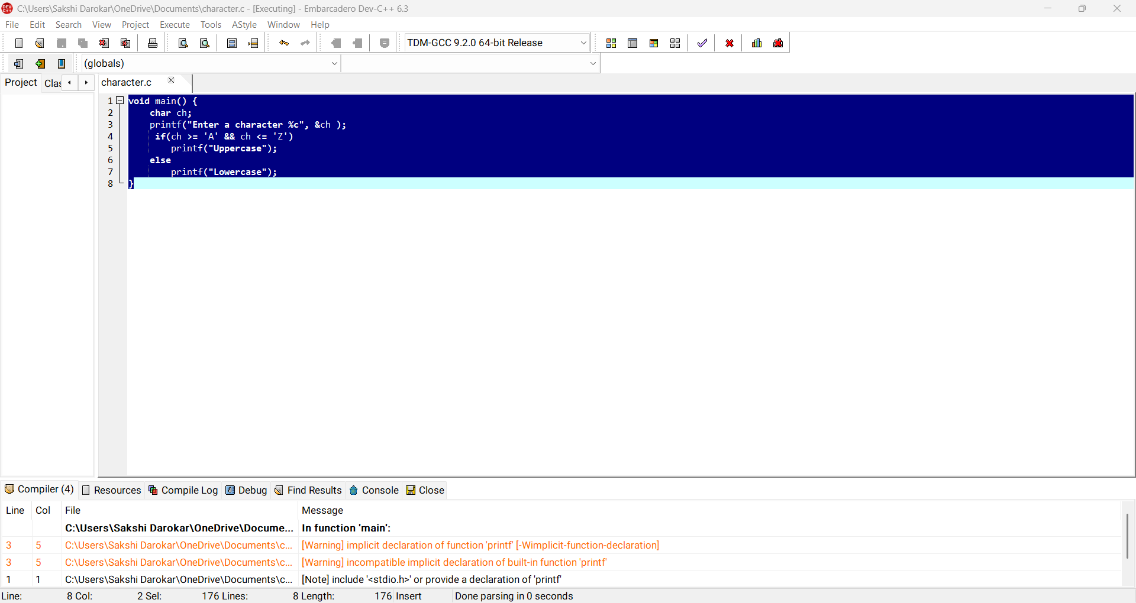

Output:

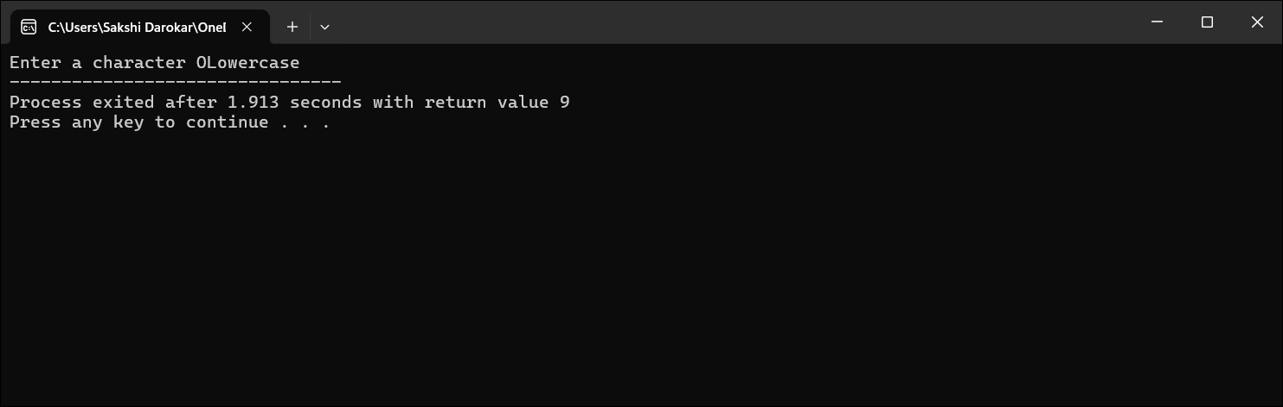

6. Calculating total salary based on basic. If basic <=5000 da, ta and hra will be 10%,20% and 25% respectively. pectively otherwise da, ta and hra will be 15%,25% and 30% respectively.

Code:

void main() {

float basic, total;

printf("Enter basic salary %f", &basic);

if (basic <= 5000)

total = basic + basic\*0.10 + basic\*0.20 + basic\*0.25;

else

total = basic + basic\*0.15 + basic\*0.25 + basic\*0.30;

printf("Total Salary = %.2f", total);

}

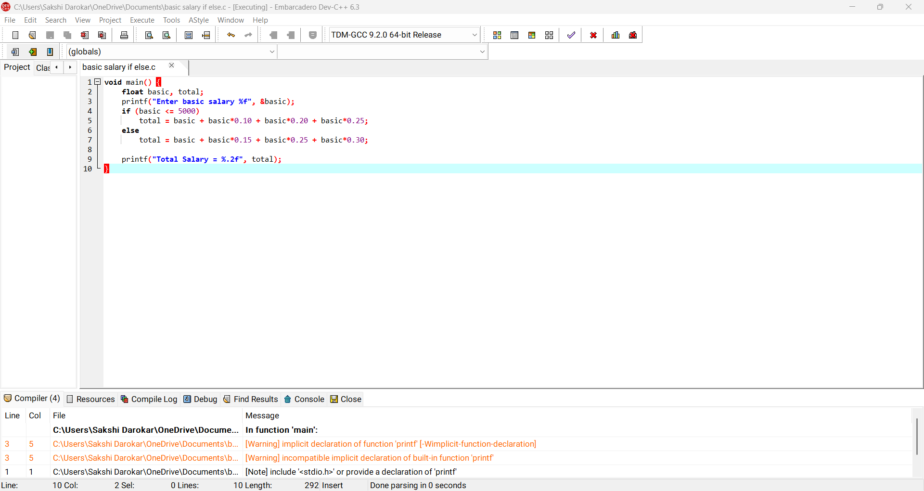

Output:

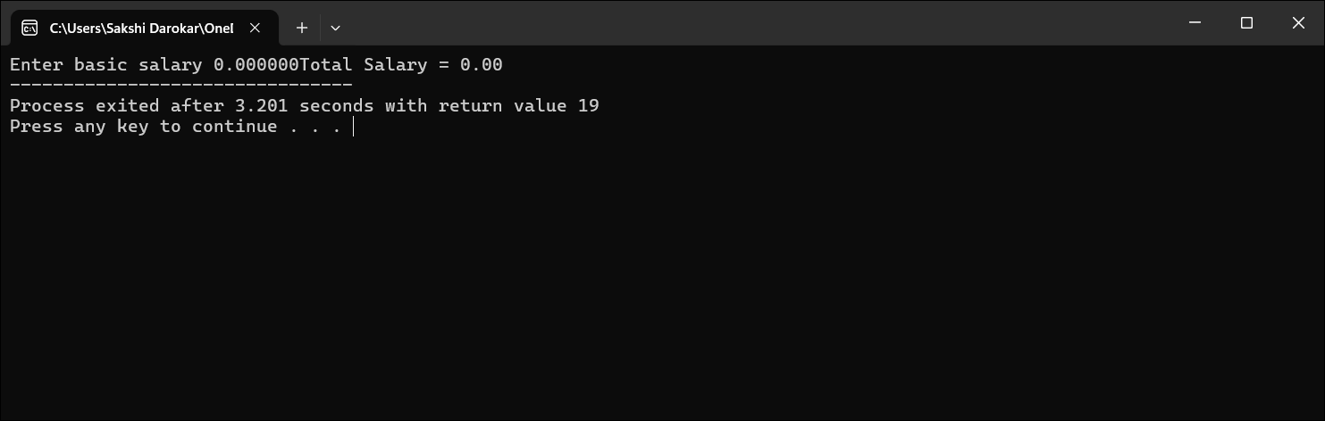

7. Write a program to check whether a given character is a vowel or consonant.

void main() {

char ch;

printf("Enter a character %c", &ch);

if (ch=='a'||ch=='e'||ch=='i'||ch=='o'||ch=='u'||

ch=='A'||ch=='E'||ch=='I'||ch=='O'||ch=='U')

printf("Vowel");

else

printf("Consonant");

}

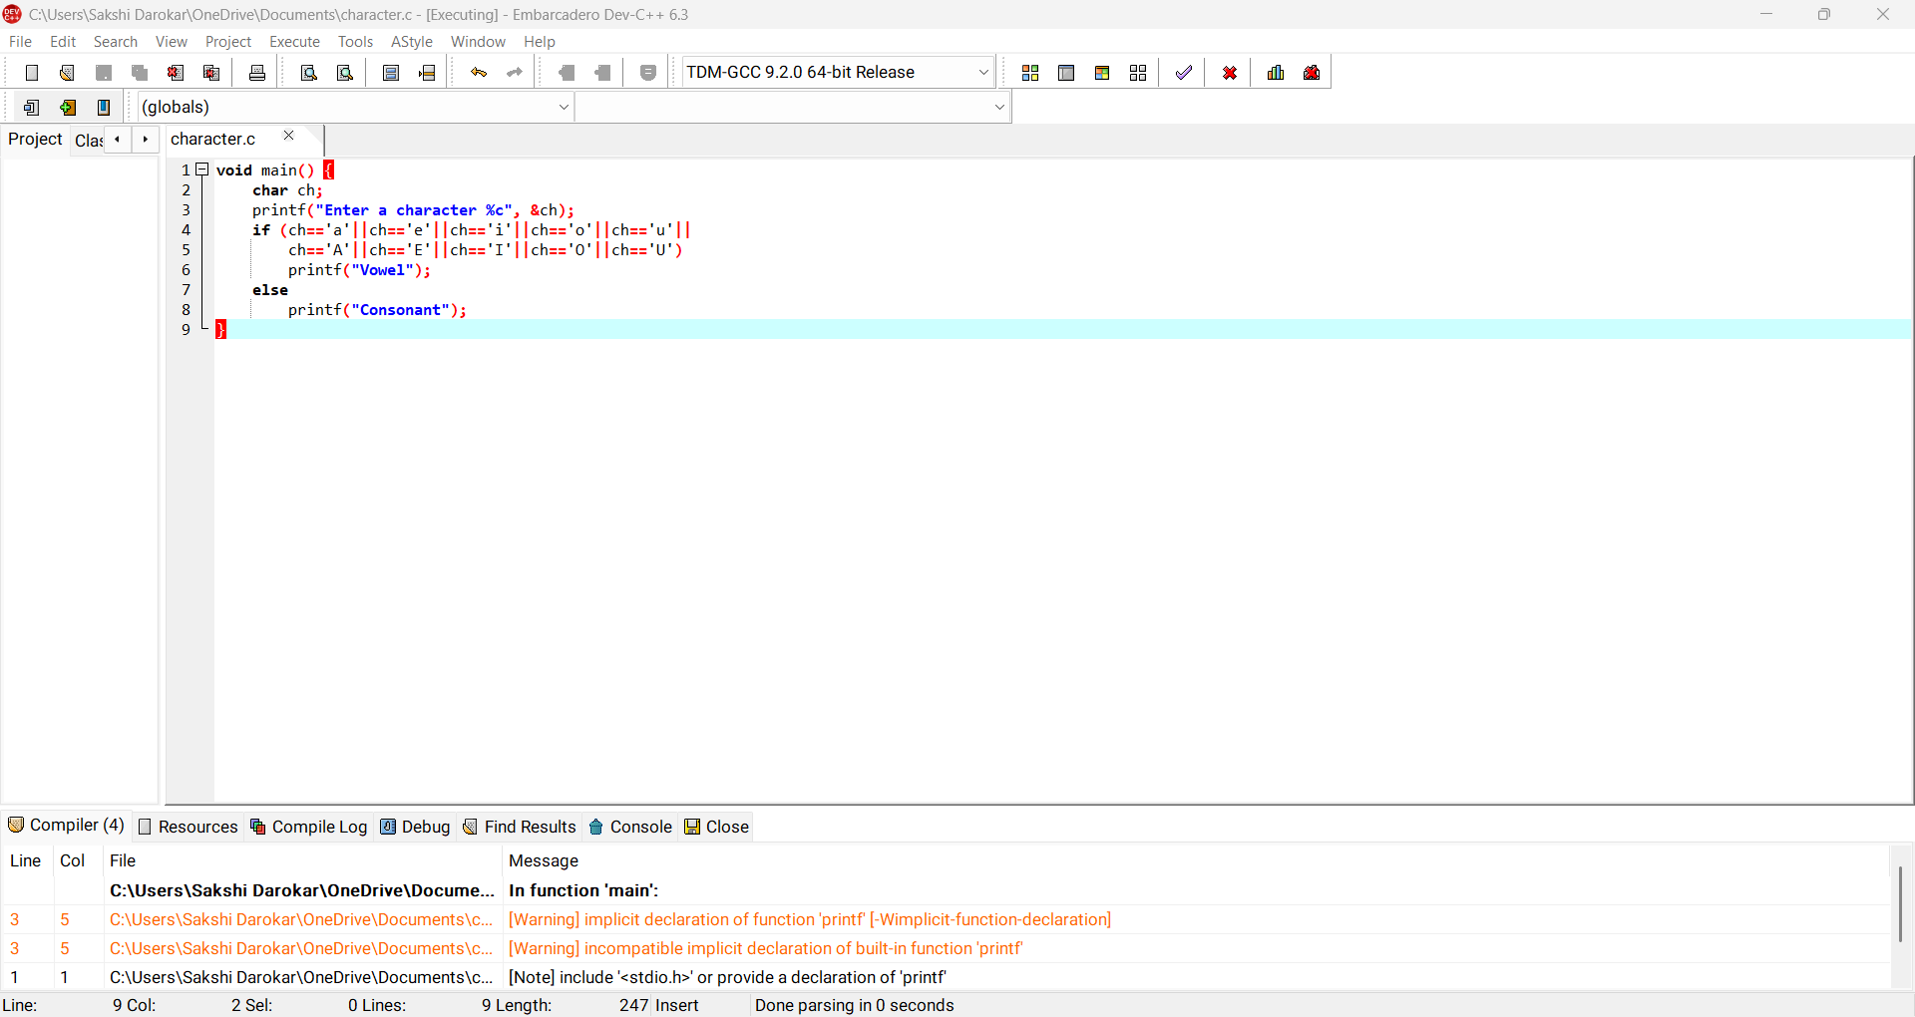

Output:

